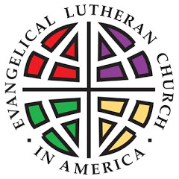
TOP SECRET
1 OF 7
06/01/2014
DATE ISSUED:
WWJD – B1B1E – 3 - 16
SECURITY CLASSIFICATION

Mission:
To honor God by serving His people as Agents of Faith.

Qualifications for Agents:
All youth in Middle School or High School next fall.

Details:
Middle School and High School Agents will gather at ELC for lunch after VBS ends at noon at Immanuel, July 7th through 11th. They’ll be placed on teams based on the grade they’re entering in the fall and according to space in vehicles when needed. Youth will return to ELC around 5:00pm, depending on each day’s events. (Each agent’s handlers will know in advance the approximate return time.) High School agents will be able to earn Silver Cord hours, Middle School agents will be able to earn hours of service for Confirmation.

Allies:
Second Harvest Food Bank, Mount Horeb Food Pantry, Blue Mounds Food Pantry, Mount Horeb Clothes Closet, Ronald McDonald House, Community Action Coalition, and more TBA.

Acceptance:
To be considered for this mission, applications must be received by Sunday, June 22nd, 2014. Initiation will begin Sunday, July 6th at 6pm with a pizza dinner at ELC. At 7:30 you’ll be released for a good night’s sleep with instructions for the next day. Applications are available online through ELC’s website: ELCMtHoreb.org, Education, Mission Week. Paper applications are also available in the office or on the bulletin board outside the chapel. A $20/youth donation is suggested.


MISSION: IMPOSSIBLE

