Youth Programs - Summer 2015
A Little Hard Work
&
A Whole Lot of Grace

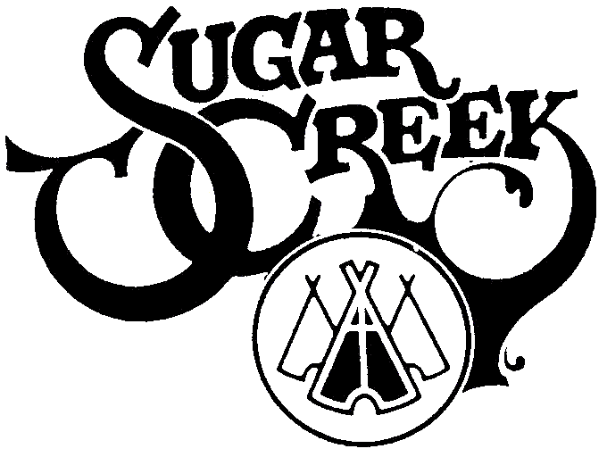

Evangelical Lutheran Church
315 East Main Street
Mount Horeb, WI
608-437-5012
ADULT VOLUNTEER REGISTRATION FORM

Name

Cell phone

Email

I want to be involved in A Little Hard Work and
A Whole Lot of Grace this summer at ELC.
(Circle the day of the week when indicated.)

___ I will bring a snack for VBS on M T W R

___ I will serve & clean up snack for VBS on M T W R

___ I will help the SC Staff with Day Camp all week AM PM All Day

___ I will bring snack for Day Camp on M T W R

___ I will help serve snack for Day Camp on M T W R

___ I have a talent/skill I’d like to share one afternoon for Day Camp

___ I will transport and accompany 5 youth for Mission Impossible on
M T W R

___ I will coordinate lunches for Mission Impossible

___ Have lunch coordinator call me and I’ll help bring or serve food.

___ I would love to host Sugar Creek staff at my house and serve
them breakfast Sunday – Thursday

___ I would love to host Sugar Creek staff for dinner on M or W

Please return this form by 6/14/2015

