ANNOUNCEMENTS-January 14th & 15th, 2023

PLEASE PRAY FOR David Field (Donna Miller & Dawn Kellesvig’s brother), Hazel Hermann, Betty Tharp(Katie Zelle’s grandmother), Ken Rabideau (Helen Ladwig’s Brother in Law), Jerome Bell, Beth Wright ( Kate Hook’s sister)Nick O’Connell, Paul Kerscher (Amy Thompson’s Dad), Donald Strube (Pete’s Dad), Steve Mueller, Joyce Fargo, Alycen McKinney, Harold “Chick” Gullickson (Brother of Mary Krantz), Cara Mavis, Amy Hall, Rollie & Joan Schraepfer ( Rita Schraepfer-Derke’s Brother & Sister in Law), Todd Collins, Norm Hefty, Lincoln Kuhn, Brooklynn Kreul, Mary Jane Ellis (friend of Bonny Kellogg), Connie Peterson, Bonnie Bender, Ginger Quaderer (Diane Mueller’s cousin), Delores Bryant, Makenzee Smith, Shirley Thompson, Brock Howe, Jeannie U’Ren, Ruth Ann Nemet, Mike Olson, Irene Bruflat, Grace Aavang, Carol Johnson.

Our partner congregation IGLESIA EVANGÉLICA LUTERANA DIVINO SALVADOR (Divine Savior Lutheran Church) in Cataño, P.R

LETTERS OF ENCOURAGEMENT appreciated for David Field who will remain in rehab for at least four weeks:

Banner Rehabilitation Hospital East
Attn: David Field
Rm 1125
1702 S. Pierpont
Mess AZ, 85206

YOUTH
SUNDAY SCHOOL 10:15 - 11 am - (3 years old - 8th grade) -Join us weekly for Bible stories, music, games, and snacks. We begin in the chapel. Next Service Day is January 22nd.

7th & 8th CONFIRMATION BOWLING NIGHT - We will have a bowling night on January 18th, 7 pm – 8:30 pm at Norsk Bowl. Please bring $5 per person. Drop off youth (and pick up) at Norsk Bowling. Pizza will be provided.

EXTRA TROLL WAY PIZZA – Didn’t get an opportunity to order? We will have extra pizzas available. Contact Brenda if you are interested. (brenda.martin@elcmthoreb.org) Pick up day for these unforgettable pizzas will be on January 29, in Fellowship Hall. (After worship services) Funds raised will support the youth ministries.

CULVERS SHARE DAY: SAVE THE DATE - JAN 16th - Stop by Culvers and help our ELC/Immanuel Youth earn money for their transportation fund to attend the ELCA Youth Gathering in 2024. Our youth will earn 7% of the sales from 8 am - 10 pm. Thank you to everyone for supporting our youth and to Culvers for this opportunity.
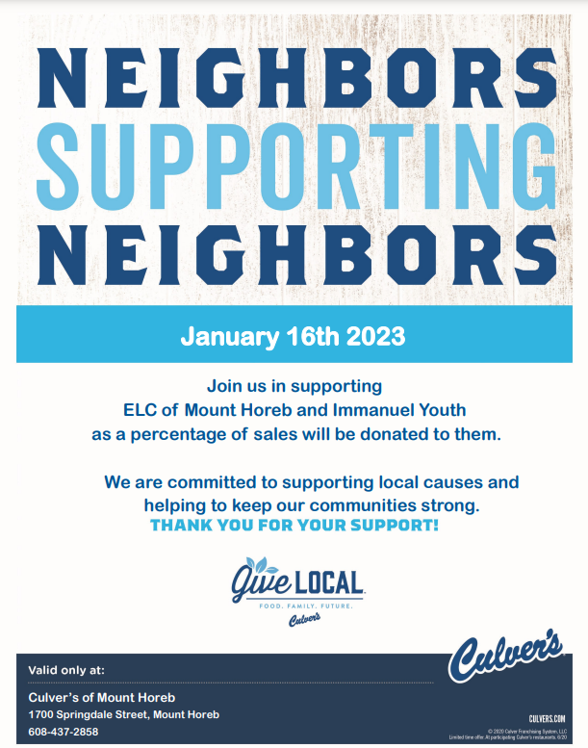

FUSE NIGHT - JAN 22nd - 7 pm – High schoolers are invited to join us for a RIC (Reconciling In Christ) event at ELC, with guest speaker Rev. Javen Swanson.

SYNOD YOUTH EVENT “ALIVE” - Feb 8th, 6 - 8 pm. Middle and High School youth are invited to a Synod youth event at Dekorra Lutheran Church in Poynette. Our confirmation youth will be attending this evening. We will leave ELC parking lot at 5 pm. We will need some drivers. We will return around 8:45 - 9 pm. Great time to meet new friends, dinner, games, worship, ice breakers and fun. RSVP with Brenda by Jan 25th.

SUGAR CREEK “JUMP INTO SUMMER” – Online Registration is open for Sugar Creek Bible Camp Summer programs. They have a variety of programs (new & favorites) listed on their website, http://wp.sugarcreek bible camp.org, for youth and families. ELC of Mt Horeb will help with camp costs, by giving each camper $100 towards their camping week. Please let Sugar Creek know that you are registering with ELC. If additional scholarships are needed, please contact Brenda or Pastor John. Come and see in 2023!

2023 YOUTH SUMMER SCHEDULE:
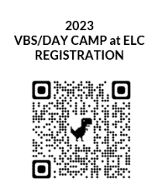
- DAY CAMP/VBS WEEK AT ELC - June 19 - 22, 2023 Register - https://forms.gle/qYotzWLkqgNXDLef6
⇨VBS (9 - 11:30 am) for 3 – Kindergarten

⇨ DAY CAMP (9 am - 3 pm) Children entering 1st - 5th in fall (One day to Sugar Creek)
- CONFIRMATION CAMP - July 9 - 14, 7th & 8th graders will attend Confirmation Camp at Sugar Creek Bible Camp. Register online: http://wp.sugarcreekbiblecamp.org/
(Use the GHRID: ELCMTH to register) ELC is paying $100 towards the registration fee for campers)

- GIVE/LOVE/SERVE (Local Service Days) - Middle - High school youth may join us on Thursdays, (July 20, 27 and Aug 3) - Youth will participate in various service opportunities in our community. Types of service: NHN, Second Harvest,
River Food Pantry.
Two links to complete. Sign up using this link - https://www.signupgenius.com/go/10C0D4DAEA929A5FFC70-giveloveserve. Please complete the registration google form for permission to participate. (QR code) https://forms.gle/muPBvDA5UpZ9RPUJ8

Potluck Brunch
What could be better than coffee and donuts? Brunch!

Spiritual Growth & Fellowship is hosting a potluck this Sunday, January15th. We’ll have brunch at about 10:30 am. Feel free to bring your favorite breakfast or lunch dish to share. Get acquainted or re-acquainted with other folks at church. All are welcome!

ELC COFFEE TIME Wednesdays at 10am in Fellowship Hall. A great time to connect with our church family

ELC SEWING DAYS - Thursdays at 9am in Fellowship Hall.

MEN’S BREAKFAST/BIBLE STUDY 1st & 3rd Thursdays at 6:30 am on Zoom. Contact Pastor John for the link.

BABY CAPS -Knitters - If you’re ready to take a break from making baby caps and eyeglass cases, on Tuesday Jan. 17 bring a ball of cotton yarn (Cookies ‘n Cream or Sugar ‘n Cream) and a pair of size 6, 7, or 8 knitting needles. We’ll work on an easy but attractive pattern for dishcloths that knit up in a flash. We’ll meet in the Faith Room at 9:30.
Contact ruthheinecke@gmail.com with questions.

REBECCA CIRCLE will meet at 9:30 instead of 10 on January 17th in Fellowship Hall. Helen will bring books for our new Study. Diane will bring cookies.

SARAH CIRCLE will meet Tuesday, January 17th at 7 pm at church. Bible study will be from the Jan/Feb issue of "Gather" magazine. Contact Connie Curran (curranconnie@hotmail.com) with any questions about the study materials or meeting details. Always welcoming new participants and those we haven't seen lately."

“Walking the Talk of Welcome”
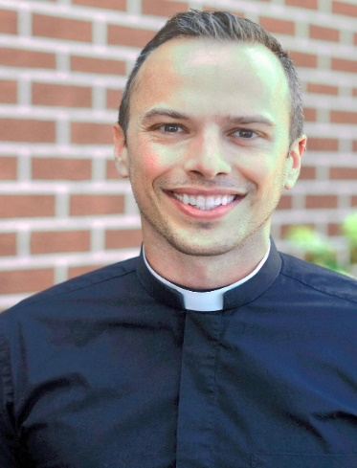
Sunday, January 22nd
Evangelical Lutheran Church of Mt. Horeb welcomes Rev. Javen Swanson.

Pastor Javen will preach for 9:00 a.m. worship, then following worship will lead a discussion in fellowship hall about how we can grow in our practices of welcome to all people as a Reconciling in Christ congregation.

At 7:00 p.m. there will be a time for youth in the congregation and community to meet with Pastor Javen to explore issues of faith, welcome and identity

The Rev. Javen Swanson (he/him/his, pronounced JAY-ven) has served since 2014 as Associate Pastor at Gloria Dei Lutheran Church in Saint Paul, Minnesota, where he has been called to assist parishioners in developing caring relationships with one another and the community, expanding and enhancing their outreach and service, and putting their gifts to use for the sake of God’s mission in the world. Prior to his ordination, Javen was a community organizer, first with OutFront Minnesota and Minnesotans United for All Families, the campaign that defeated an anti-gay marriage amendment and went on to legalize marriage for same-sex couples in Minnesota, and later with the National LGBTQ Task Force. A graduate of Gustavus Adolphus College and Yale Divinity School, Javen now lives in Saint Paul with his husband, the Rev. Oby Ballinger, their cat Amos, and their dog Ruthie.
Javen was once a confirmation student in my church in Pine River MN, and remains a good friend to our family.

I knew early on that Javen had the gifts and the curiosity to excel at ministry, but when he was in school the church was not ready to accept him, as a gay man, into the ministry. I’m so very grateful that the ELCA has been willing to receive the gifts of those who were previously excluded.

Our congregation has expressed our desire to be a place of welcome for all people, and I’ve invited Javen to be with us to talk about his journey, and help us think about what it means to share true hospitality

I hope you’ll plan to be with us for the day. -Pastor John Twiton


HOURS
MONDAY-THURSDAY 9AM – NOON
and 1PM-4PM
FRIDAYS 9AM-NOON

STEEPLE ECHOES ARTICLES DUE BY Thursday January 19th

ANNUAL GIVING STATEMENTS ARE NOW AVAILABLE:
To save paper and cut down on mailing costs, we're trying an opt-in system for yearly giving statements. If you'd like a summary of your 2022 giving, please contact the office at elc@mhtc.net

VOLUNTEERS NEEDED on Tuesday, January 24th to assemble the February newsletter. Newcomers are welcome. The assembly process usually takes about 2 hours. Please, come and enjoy the fellowship.

THANKYOU FOR ASSISTING WORSHIP
 | This Week  Jan. 14th & 15th | Next Week  Jan.21st & 22nd
READERS | - Bonny Kellogg  - Steve Knuteson | - Ann Baumgartner  - Ben Brothers
ACOLYTES | - Kayla Bredeson  - Michael Powell | - Zoe Stack  - Evelyn Wyse
COMM. ASSIST. | No Communion | - Greg & Amy Kellesvig  - Deb Dangerfield
USHERS | Team 3  Dennis Lokken  Irv Steinhauer | Team 4  Doug Nesheim  Gerald Stamn
NURSERY | Open but Not Staffed-Located across from the library
ALTAR GUILD | Cathie Field, Sara Hellenbrand, Amy Kellesvig,  Laura Miller, Sharon Schiefelbein, Bev Schwierske
COUNCIL  DUTIES | Serena Vondra
Grace-The exercise of love, kindness, mercy, favor and the disposition to serve another.

